**Module 7 Homework: A Day in the Life of a Windows Sysadmin-Brenda Schecher**

**Task 1- Create a GPO: Disable Local Link Multicast Name Resolution (LLMNR)**

1. **Got to Windows Server via Hyper-V**
2. **Log in and go to Group Policy Management, Domains, then Goodcorp.net**
3. **right-click Group Policy Objects**
4. **New**
5. **Name of Group: No LLMNR**
6. **Right click No LLMNR and click computer configuration, Policies, Administratiive Templates, Network, DNS Client.**
7. **Enable “Turn off Multicast Name Resolution”**
8. **Group Policy Management right click GC Computers. Link to existing GPO : No LLMNR.**

**Task 2-Create a GPO: Account Lockout-**

1. **Group Policy Management Group Policy Objects, New Policy and add Account Lockout.**
2. **Right click new GPO Account Lockout to edit policy. Computer Configuration, Policies, Windows Settings, Security Settings, and Account Lockout Policy.**
3. **I set it for the following-**
   1. **Account Lockout Duration-10 minutes**
   2. **Account Lockout Threshold- 15 valid login attempts**
   3. **Reset Account Lockout Counter after-10 minutes**

**Task 3-Create a GPO: Enabling Verbose PowerShell Logging and Transcription**

1. **Group Policy Management to Group Policy Objects. Create new GPO new Powershell Logging.**
2. **PowerShell Logging, Edit, Computer Configuration, Policies, Admin templates, Windows components, Windows PowerShell, Turn on Module Logging, turn on PowerShell script block logging, turn on script execution (allow all scripts) turn on PowerShell transcripts (enable).**
3. **Link PowerShell Logging GPO to GC Computers.**

**Task 4-Create a Script: Enumerate Access Control Lists**

**Create Shell script in NotePad in Directory Users\sysadmin\Documents\enum_acls.ps1**

Task 4 shell scripts

$directory = Get-ChildItem

foreach ($item in $directory) {

Get-Acl $item

**Run script Powershell**

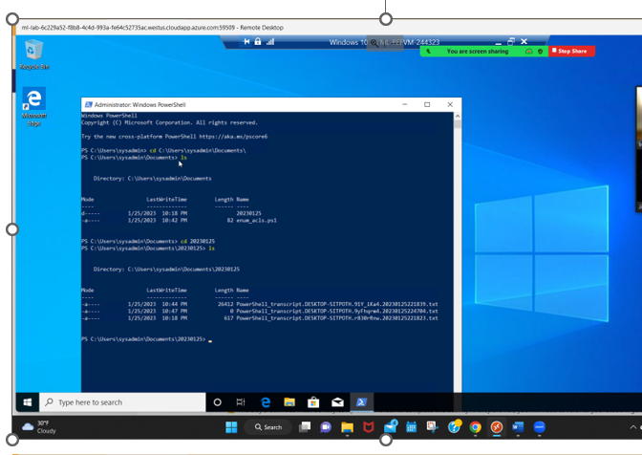

**Bonus-Task 5 Verify your Powershell Logging GPO-**

